eWEEK – Fine-Grained Access ControlWith OpenHack
Oracle9i R2 RDBMS
John Abel, Oracle UK Consulting (john.abel@oracle.com)
Per eWeek’s request, Oracle prepared the following documentation to describe Oracle’s Fine-Grained Access Control. This document outlines how Fine-Grained Access Control could have been added to OpenHack and focuses on ease of implementation. Other security methods have been used to harden the application/database, which were defined in a separate document.

Building Secure Applications on top of Oracle
Both commercial off-the-shelf applications and custom-built applications can take advantage of its granular access control, without the need to revise any lines of application code.

Fine-Grained Access Control Overview
Oracle embeds Virtual Private Database (VPD) fine-grained access functionality as part of the core Oracle8i/Oracle9i Database Enterprise Edition. In addition, Oracle offers Oracle Label Security (OLS), an out-of-the-box option, with Oracle9i Database Enterprise Edition. With either VPD or OLS, Oracle9i Database offers unique data access control down to the row-level. This article focuses on the use of VPD as a key security component in the Oracle9i Openhack application.

Fine-Grained Access Control
Virtual Private Database, unique to Oracle, secures data at the lowest levels of access offered by any commercial RDBMS. It provides a flexible mechanism for creating applications that can consistently enforce enterprise-wide security policies. Fine-grained access control is implemented via the DBMS_RLS package [and uses SYS_CONTEXT to pass security labels]. By dynamically appending SQL statements with a predicate, VPD limits access to data at the row level and ties the security policy to the table (or view or synonym) itself. Virtual Private Database is enforced at the database layer and takes into account application-specific logic used to limit data access within the database. VPD policies are enforced no matter how any user accesses the data, be it through applications or via direct queries.

Oracle Label Security
Built on VPD's fine grained access control technology, Oracle9i Label Security (OLS) is an out-of-the-box, independently evaluated, security system supplied by Oracle to mediate access to data by comparing a sensitivity label assigned to a piece of data with label authorizations assigned to an application user. OLS is unique to Oracle and is designed to meet the stringent requirements for row level security found in government and commercial organizations. OLS enables applications to take advantage of database enforced multilevel security technologies. The primary differences between VPD and OLS are that OLS provides the security software out-of-the-box as well as a robust infrastructure for managing sensitivity labels and user label authorizations. With VPD, the security package is designed and coded by software developers. Both are enforced in the database and the VPD enforcement mechanism has been evaluated. Law enforcement, national security, healthcare, franchise management, energy and franchise management are just a few of the areas that can benefit for Oracle9i label Security. Examples of sensitivity labels include [Top Secret : Homeland Security], [Confidential : Patient, Physician Only] and [Sensitive : Asia, Legal, Corporate Acquisition].

Case Study using OpenHack Application
The following is an example of Fine-Grained Access Control (Virtual Private Database) within the OpenHack environment.

Schema Overview
Figure 1 shows schema owners and access rights. This example can be enhanced for more complex environments. Note: Not all schema objects are provided.

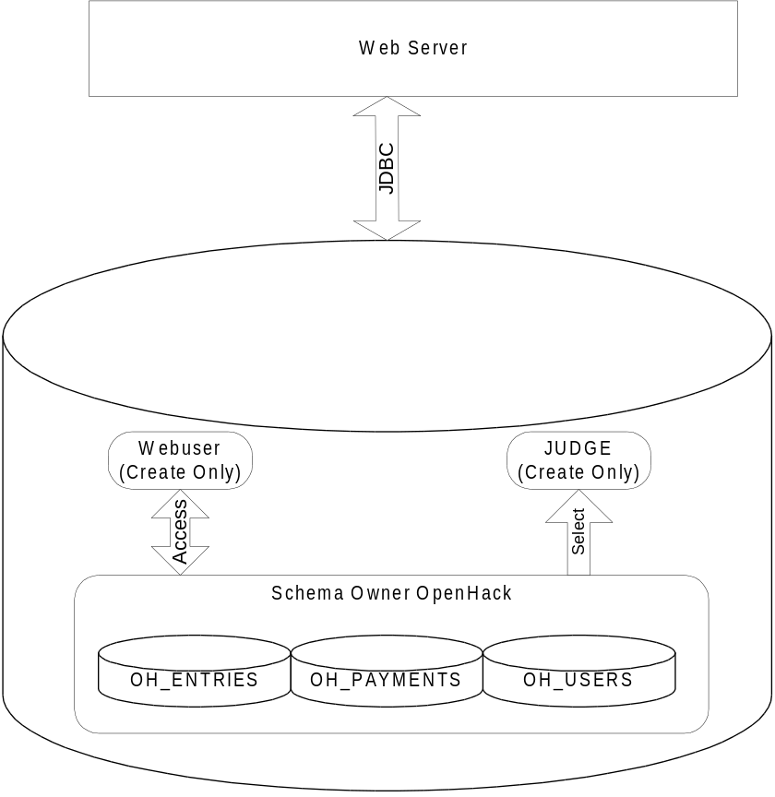
Figure 1
Data Access Rights
The following are the access writes and groupings that are required per “virtual user” (e.g. OH_USERS) and database users (e.g. JUDGE).

Database User / Virtual User | Access Right |  | Description
Web User / Individual Entries in OH_USERS | INSERT, UPDATE and SELECT | OH_USERS | Allowed maintain user details, and create a new user row.
Web User / Individual Entries in OH_USERS | INSERT, UPDATE, SELECT and DELETE | OH_PAYMENTS | Allowed to maintain only user rows
Web User / Individual Entries in OH_USERS | INSERT, UPDATE, SELECT and DELETE | OH_ENTRIES | Allowed to maintain only user rows
Judge User | SELECT | OH_ENTRIES | All rows available to user

Program Access Rights
Another requirement is to confirm the program or application trying to access the data within the database. Within an application, a “rouge” program (e.g. hacker may place an execution script using a vulnerability) may try and access the database to obtain data. As a result, validation of execution code is required.

Oracle’s Solution to Openhack’s Requirements
Oracle’s solution is based on software methods standard to Oracle9i Database Enterprise Edition. Please note, each solution component can be added to an existing application without incurring the cost of a major code re-write. The example provided is the starting position and should be used as guidance.

Program Access Rights
Figure 2 illustrates key security issues regarding data access when connecting to a database applicaton.

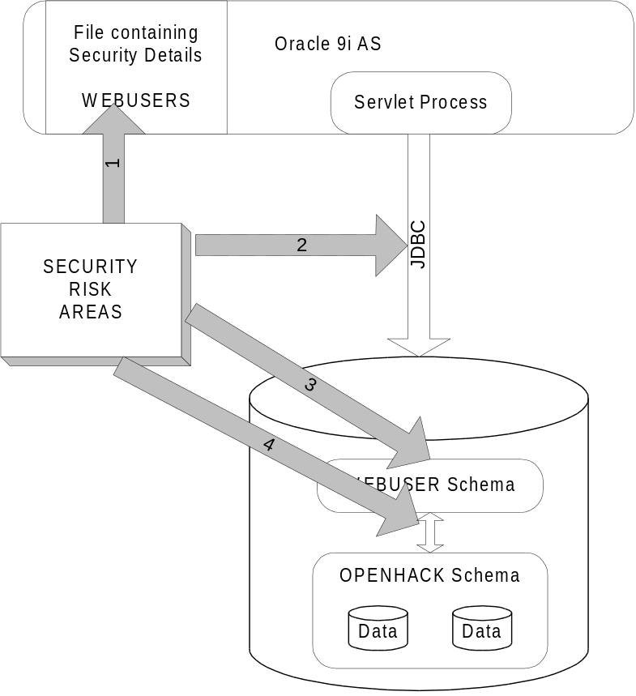

Figure 2
The following are the definitions of the security issues. Note not all security issues are shown, but the most common are defined.
1. Security Issue 1: within a security file (e.g. WEB.XML) the security details can be defined. They are visible to administrators or hackers who can break out of the application server code or modified.
2. Security Issue 2: JDBC connection is in the “clear” and data can be observed by unauthorized users.
3. Security Issue 3: once connected as database user, then access is possible to user’s application data.
4. Security Issue 4: Access is possible to underlying granted schema objects. DML and SELECT operations can be performed with grants provided.

Security Issue 1 Resolution
Most application environments have the username, password and connect string stored in an application file; so, if a vulnerability exists (e.g. some can access the secure file), the password is exposed. To resolve this we must add some key that is only known to the execution code. So, a possibility could be to store the key within a secure hardware device, but additional expense will be incurred or store the key with shared object cache. Using Oracle9iAS R2, it is possible to have a Servlet setup a distributed java object containing the key; this could be part of a single or group of JVM’s. The key would be used to validate the calling application when accessing data. Using the Virtual Private Database, accessing data objects (e.g. select … from oh_users) will be validated against the encryption key provided (see Figure 3).

Security Issue 2 Resolution
Data In “Clear”
Now as the data streams are in the clear using a standard JDBC connection, the key may be visible to a hacker tracing data packets. This can be addressed by using a JCE provider within the Web Application and creating a Triple DES (DES3) encrypted key to send the data encrypted and allow the procedure to access the DBMS_OBFUSCATION_TOOLKIT package to decrypt. NOTE: All PL/SQL packages, procedures, functions should be “wrapped” using the wrap function that Oracle provides as standard to obfuscate PL/SQL code (see Figure 3). Another possible solution is to use the Oracle Advanced Security option and encrypt all data sent from Web Server to Database.

Access From Unauthorized servers
To protect access from authorized servers, setup the TNS listener to only except packets from authorized server, again this is possible via standard features. Add the following entries to the SQLNET.ora on the database server.

tcp.validnode_checking = yes
tcp.invited_nodes = (Web Server Name or IP Address, IP Address)

Note that IP address, by itself, is not bulletproof, but it adds another layer of complexity to the hacker attempting to use a rouge application.

Security Issue 3 Resolution
Issue 3 can be addressed by protecting the data within the application schema using Fine-Grained Access. The following are code extracts that show how protection of data can occur.

1) Create a table containing the Application Key within the OpenHack Schema, no grants to any other users.
2) Create a label function to valuate the Key

Procedure setApplicationKey
…
BEGIN
Select from key table encrypted key and validate against encrypted key passed with SYS_CONTEXT from calling application.

If Match then
set DBMS_SESSION.SET_CONTEXT(‘appprivs’,’application’,’OPEN’)
else
set DBMS_SESSION.SET_CONTEXT(‘appprivs’,’application’,’CLOSED’)
END
3) Create Login trigger to call setApplicationKey

CREATE OR REPLACE TRIGGER OH_security_trigger
AFTER LOGON
ON DATABASE
CALL openhack.setApplicationKey

4) Now Create a SecureAccess Package, which will define the additional dynamic ‘Where Clause’

Package APP_SEC
…
Function SecureAccess
BEGIN
IF SYS_CONTEXT(‘appprivs’,’application’) = ‘CLOSED’ THEN
l_predicate := ‘1 = 2’;
ELSE
l_predicate := ‘’;
END IF;
RETURN l_preidcate
END
;
5) Now Add the Policy to each table that require secure application access.

EXECUTE
DBMS_RLS.ADD_POLICY(
'OPENHACK',
'OH_ENTRIES',
'OH_POLICY',
'OPENHACK',
'APP_SEC.SecureAccess',
'<Access, e.g. SELECT', …
);

Security Issue 4 Resolution
As Issue 3 adds a security policy using VPD then data access will restricted to code with the correct key. Also additional security can be added by only providing direct grants (e.g. grant create session to webuser), do not use public roles (e.g. RESOURCE, DBA, etc). Also provide minimal application grants (e.g. grant select on OH_ENTRIES).

Data Access Rights
Data Access rights are an extension to the security policy we have already created in Security Issue 3. Data Security Access or Row Level Access is when certain rows are visible to a user process. An example of this is below:

User Id CompanyA

Entries Product A
Entries Product B

User Id CompanyB

Entries Product C

U ser CompanyA should only see Entries Product A and B within OH_ENTRIES. If the following select without VPD was performed in SQL*PLUS using standard SELECT privileges, all rows would be visible.

SELECT PRODUCT FROM OH_ENTRIES;
Results: Product A
Product B
Product C

We could add a Where clause (e.g. WHERE userid = ‘ComapnyA’), but some products will not force this additional condition. So implement a VPD policy to protect rows, the only changes needed are SecureAccess and calling application.

Once the VPD policy is applied to the OH_ENTRIES table, the same user can issue the same SELECT, and the database would return only the rows he has access to:
SELECT PRODUCT FROM OH_ENTRIES;
Results: Product A
Product B

The following are the code additions that have to be made

Package APP_SEC
…
Function SecureAccess
BEGIN
IF SYS_CONTEXT(‘appprivs’,’application’) = ‘CLOSED’ THEN
l_predicate := ‘1 = 2’;
ELSE

IF SYS_CONTEXT('userenv','session_user') = ‘JUDGE’ THEN
l_predicate := ‘’;
ELSE
L_predicate := ‘COMPANY_ID IN
(SELECT COMPANY_ID FROM OH_USER_COMPANIES
WHERE USER_ID = SYS_CONTEXT('||''''||
'app_context'||''''||',
'||''''||'currentuser'||
''''||')'||')';
END IF;
END IF;
RETURN l_preidcate
END

As JDBC connections will be shared between users, application context needs to be set on SQL execution. To perform this a new SQL function needs to be called in the JSP as below:

DBMS_SESSION.SET_CONTEXT('app_context', currentuser, :user_id);

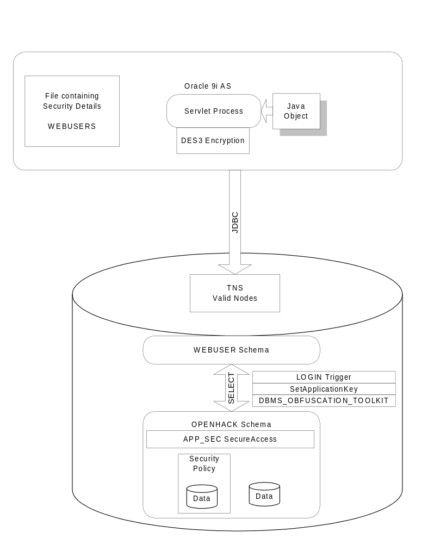
Figure 3

Conclusion
The above OpenHack environment devised by Oracle demonstrates that users can easily incorporate standard Oracle security without embarking on a costly and time-consuming major rewrite of an application. .

